WT Assignment 10
Neeti Kurulkar
Web application using EJB.

Folder Structure:
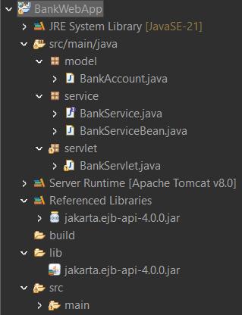

Code:
- BankAccount.java

app.controller('RegisterController', function($scope, $location, AuthService) {
$scope.user = {};

$scope.register = function() {
if ($scope.user.firstName && $scope.user.lastName && $scope.user.username && $scope.user.password) {
AuthService.register($scope.user);
alert("Registration successful!");
$location.path('/login');
} else {
alert("Please fill out all fields.");
}
};
});

app.controller('LoginController', function($scope, AuthService) {
$scope.credentials = {};

$scope.login = function() {
if (AuthService.login($scope.credentials)) {
var user = AuthService.getUser();
alert("Welcome, " + user.firstName + "!");
} else {
alert("Invalid username or password.");package model;

public class BankAccount {
private String accountNumber;
private double balance;

public BankAccount(String accountNumber) {
this.accountNumber = accountNumber;
this.balance = 1000.0; // default balance
}

public String getAccountNumber() {
return accountNumber;
}

public double getBalance() {
return balance;
}

public void deposit(double amount) {
balance += amount;
}

public boolean withdraw(double amount) {
if (balance >= amount) {
balance -= amount;
return true;
}
return false;
}
}
}
};
});

- BankService.java

package service;

import model.BankAccount;

public interface BankService {
void deposit(BankAccount account, double amount);
boolean withdraw(BankAccount account, double amount);
double getBalance(BankAccount account);
}

- BankServiceBean.java

package service;

import jakarta.ejb.Stateless;
import model.BankAccount;

@Stateless
public class BankServiceBean implements BankService {

@Override
public void deposit(BankAccount account, double amount) {
account.deposit(amount);
}

@Override
public boolean withdraw(BankAccount account, double amount) {
return account.withdraw(amount);
}

@Override
public double getBalance(BankAccount account) {
return account.getBalance();
}
}

- BankServlet.java

package servlet;

import model.BankAccount;
import service.BankService;
import service.BankServiceBean;

import javax.servlet.*;
import javax.servlet.http.*;
import java.io.IOException;
import java.io.PrintWriter;

public class BankServlet extends HttpServlet {
private final BankService service = new BankServiceBean();
private final BankAccount account = new BankAccount("123456");

protected void doPost(HttpServletRequest request, HttpServletResponse response)
throws ServletException, IOException {

String action = request.getParameter("action");
double amount = Double.parseDouble(request.getParameter("amount"));

response.setContentType("text/html");
PrintWriter out = response.getWriter();

if ("deposit".equals(action)) {
service.deposit(account, amount);
out.println("<h2>Deposited " + amount + "</h2>");
} else if ("withdraw".equals(action)) {
boolean success = service.withdraw(account, amount);
if (success) {
out.println("<h2>Withdrew " + amount + "</h2>");
} else {
out.println("<h2>Insufficient Balance</h2>");
}
}

out.println("<h3>Current Balance: " + account.getBalance() + "</h3>");
out.println("<a href='index.html'>Back</a>");
}
}

- Index.html

<!DOCTYPE html>
<html>
<head>
<title>Bank App</title>
</head>
<body>
<h2>Simple Bank Transaction</h2>
<form action="BankServlet" method="post">
Amount: <input type="number" name="amount" step="0.01" required><br><br>
<button type="submit" name="action" value="deposit">Deposit</button>
<button type="submit" name="action" value="withdraw">Withdraw</button>
</form>
</body>
</html>

- Web.xml

<web-app xmlns="http://java.sun.com/xml/ns/javaee"
version="3.0">
<servlet>
<servlet-name>BankServlet</servlet-name>
<servlet-class>servlet.BankServlet</servlet-class>
</servlet>
<servlet-mapping>
<servlet-name>BankServlet</servlet-name>
<url-pattern>/BankServlet</url-pattern>
</servlet-mapping>
</web-app>

Output:

